CSS ISLAMIC STUDIES · T2QA
بِسۡمِ ٱللَّهِ ٱلرَّحۡمَٰنِ ٱلرَّحِيمِ
Topic II — Islamic Worships (Ibadat) and Their Impact
The Question Answers · Every past-paper question of Topic 2, 2015–2026, answered as a model
Six model answers — Salah, three Zakat questions answered in three different shapes, Hajj and Fard Kifayah. Each begins with an answer map that states exactly what the question asks, builds its headings from the question's own words, and proves every heading from the Quran, the Sunnah and the scholars.
Edition of September 2026 · covers the papers of 2015–2026 · written for CSS 2027 and after
Contents
HOW TO BUILD THE CONTENTS
The Contents below is left empty on purpose. In Microsoft Word, right-click anywhere on the grey line below and choose Update Field → Update entire table → OK. The full table of contents with page numbers will appear.
On a Mac: right-click (or Control-click) the line → Update Field. If you edit the notes later, repeat this step to refresh the page numbers. You can also press Ctrl + A then F9 (Windows) to update every field in the document at once.

How to Use These Answers 5
What is in this document 5
How every answer is built 5
Answer 1 · Prayer: Meaning, Categories and Impact (CSS 2016) 6
Decoding the question 6
The model answer 7
(1) Introduction 7
(2) The meaning of prayer 7
(3) The status of prayer 7
(4) The categories of prayer 8
(5) The spiritual impact of prayer 9
(6) The moral impact of prayer 10
(7) The social impact of prayer 11
(8) A misconception answered: 'Prayer is only a ritual — being a good person is enough' 12
(9) Conclusion 13
Why this answer scores 13
Answer 2 · The Importance of Zakat and Economic Stability (CSS 2015) 14
Decoding the question 14
The model answer 15
(1) Introduction 15
(2) The meaning of Zakat 15
(3) The importance of Zakat 15
(4) Proof: how Zakat ensures economic stability 16
(5) The condition: effective implementation 18
(6) Objections answered 18
(7) Conclusion 19
Why this answer scores 19
Answer 3 · The Recipients of Zakat, Its Social Impact and Poverty Alleviation (CSS 2017) 20
Decoding the question 20
The model answer 21
(1) Introduction 21
(2) Who is entitled to receive Zakat — the Quranic text 21
(3) The social impact of Zakat 23
(4) How poverty can be alleviated through the distribution of Zakat 23
(5) The conditions that make distribution effective 24
(6) Conclusion 25
Why this answer scores 25
Answer 4 · The Zakat System and Its Spiritual, Moral and Social Impacts (CSS 2018) 26
Decoding the question 26
The model answer 27
(1) Introduction 27
(2) The meaning and status of Zakat 27
(3) The Zakat system 27
(4) The spiritual impacts of Zakat 29
(5) The moral impacts of Zakat 30
(6) The social impacts of Zakat 30
(7) Zakat in history — the system at work 31
(8) Conclusion 32
Why this answer scores 32
Answer 5 · The Hajj System and Its Spiritual, Moral and Social Impacts (CSS 2019) 33
Decoding the question 33
The model answer 34
(1) Introduction 34
(2) Meaning and obligation 34
(3) The Hajj system 35
(4) The spiritual impacts of Hajj 36
(5) The moral impacts of Hajj 37
(6) The social impacts of Hajj 37
(7) Hajj, Umrah and Qurbani — the wider system 38
(8) Conclusion 38
Why this answer scores 39
Answer 6 · Farz Kifayah: Meaning, Significance and Modern Scope (CSS 2025) 40
Decoding the question 40
The model answer 41
(1) Introduction 41
(2) The meaning of Farz Kifayah 41
(3) The religious significance of Farz Kifayah 43
(4) The social significance of Farz Kifayah 43
(5) The scope of Farz Kifayah in the present era 44
(6) When the collective duty becomes personal — and who organises it 45
(7) Conclusion 45
Why this answer scores 45

How to Use These Answers

What is in this document
# | Paper | Question (short) | Answer
1 | 2016 Q5 | Meaning and categories of prayer; its spiritual, moral and social impact | Answer 1
2 | 2015 Q5 | Importance of Zakat; proof that it ensures economic stability | Answer 2
3 | 2017 Q2 | Recipients of Zakat; its social impact; poverty alleviation | Answer 3
4 | 2018 Q6 | The Zakat system; its spiritual, moral and social impacts | Answer 4
5 | 2019 Q6 | The Hajj system; its spiritual, moral and social impacts | Answer 5
6 | 2025 Q3 | Farz Kifayah: meaning, significance, modern scope | Answer 6

The three Zakat questions are answered with three different structures, as the examiner's three different wordings demand: 2015 is built on proof of stability, 2017 on recipients and poverty, 2018 on the system and its impacts.

How every answer is built
1. The question, exactly as set.
2. The answer map — the centre states exactly what the question asks, limb by limb; every box is a heading of the answer, and every point is a complete idea (the verse and its point, not only the surah's name).
3. Decoding the question — the command words and what each limb demands.
4. The model answer — headings from the question's own words, sub-headings to three levels, evidence inside every heading, figures, the Pakistan angle, and a conclusion with a verse or hadith.
5. Why this answer scores.
TRAP · USE THE ANSWERS AS MODELS, NOT SCRIPTS
Learn the structure and the evidence; build your headings from the words of the question you are given. A model answer is fuller than you can write in 33 minutes — choose the headings and evidence you can reproduce well.

Answer 1 · Prayer: Meaning, Categories and Impact (CSS 2016)
THE QUESTION · CSS 2016 · Q5 · 20 marks
Define the meaning of prayer and its different categories. Also describe the spiritual, moral and social impact of prayers.

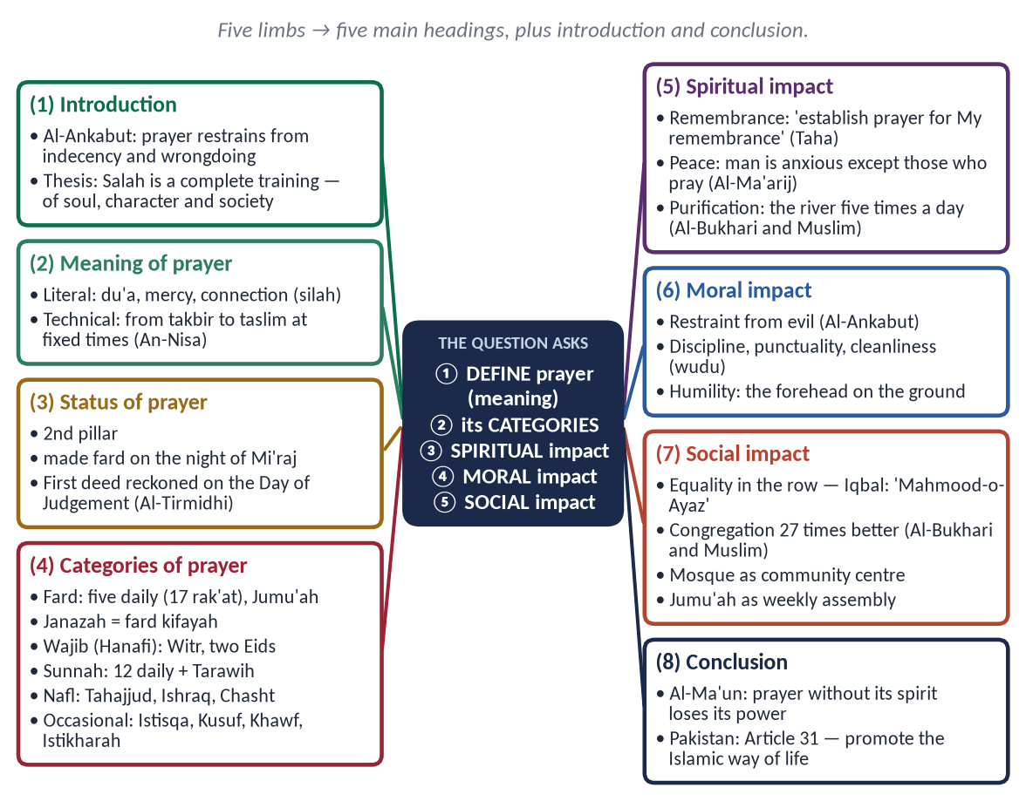
Figure 1 · The answer map: every branch is one numbered heading of the model answer below.

Decoding the question
- Five limbs: meaning · categories · spiritual impact · moral impact · social impact. Each needs its own heading; the three impacts should carry the most weight.
- 'Define' = literal and technical meaning, with evidence.
- 'Different categories' = a classification (use the Hanafi one), not a description of how to pray.
- 'Describe' the impacts = explain how prayer produces each effect, with evidence.

The model answer

(1) Introduction
✦ QURAN
﴿ٱتۡلُ مَآ أُوحِيَ إِلَيۡكَ مِنَ ٱلۡكِتَٰبِ وَأَقِمِ ٱلصَّلَوٰةَۖ إِنَّ ٱلصَّلَوٰةَ تَنۡهَىٰ عَنِ ٱلۡفَحۡشَآءِ وَٱلۡمُنكَرِۗ وَلَذِكۡرُ ٱللَّهِ أَكۡبَرُۗ وَٱللَّهُ يَعۡلَمُ مَا تَصۡنَعُونَ﴾
“Recite, [O Muhammad], what has been revealed to you of the Book and establish prayer. Indeed, prayer prohibits immorality and wrongdoing, and the remembrance of Allah is greater. And Allah knows that which you do.” (Al-Ankabut, Quran)
➜ 'Recite what has been revealed to you of the Book and establish prayer. Indeed, prayer restrains from indecency and wrongdoing, and the remembrance of Allah is greater.'

Salah is the second pillar of Islam and the most frequent act of worship: five times a day, every day of an adult Muslim's life. The Quran does not present it as a ritual only, but as a force that restrains from evil and a means of remembrance. This answer defines prayer, sets out its categories, and describes its spiritual, moral and social impact — showing that Salah is a complete programme for training the soul, the character and the society.

(2) The meaning of prayer

(i) Literal meaning
Salah means supplication (du'a) and mercy; many scholars link it to silah, 'connection' — the link between the servant and his Lord.

(ii) Technical meaning
Salah is a specific act of worship, beginning with the takbir and ending with the taslim, consisting of standing, recitation, bowing and prostration, performed at fixed times with its conditions.
✦ QURAN
﴿… إِنَّ ٱلصَّلَوٰةَ كَانَتۡ عَلَى ٱلۡمُؤۡمِنِينَ كِتَٰبٗا مَّوۡقُوتٗا﴾
“Indeed, prayer has been decreed upon the believers at fixed times.” (An-Nisa, Quran)
➜ 'Prayer has been decreed upon the believers at fixed times.'

(3) The status of prayer
- (a) The second pillar of Islam, after the Shahadah.
- (b) Made obligatory in the heavens, on the night of the Mi'raj.
- (c) The first deed to be reckoned on the Day of Judgement:
✦ HADITH
إِنَّ أَوَّلَ مَا يُحَاسَبُ بِهِ الْعَبْدُ يَوْمَ الْقِيَامَةِ مِنْ عَمَلِهِ صَلَاتُهُ
“The first of his deeds for which a servant will be called to account on the Day of Resurrection is his prayer.” (Al-Tirmidhi)
➜ Salah is the foundation on which the rest of the record stands.

(4) The categories of prayer
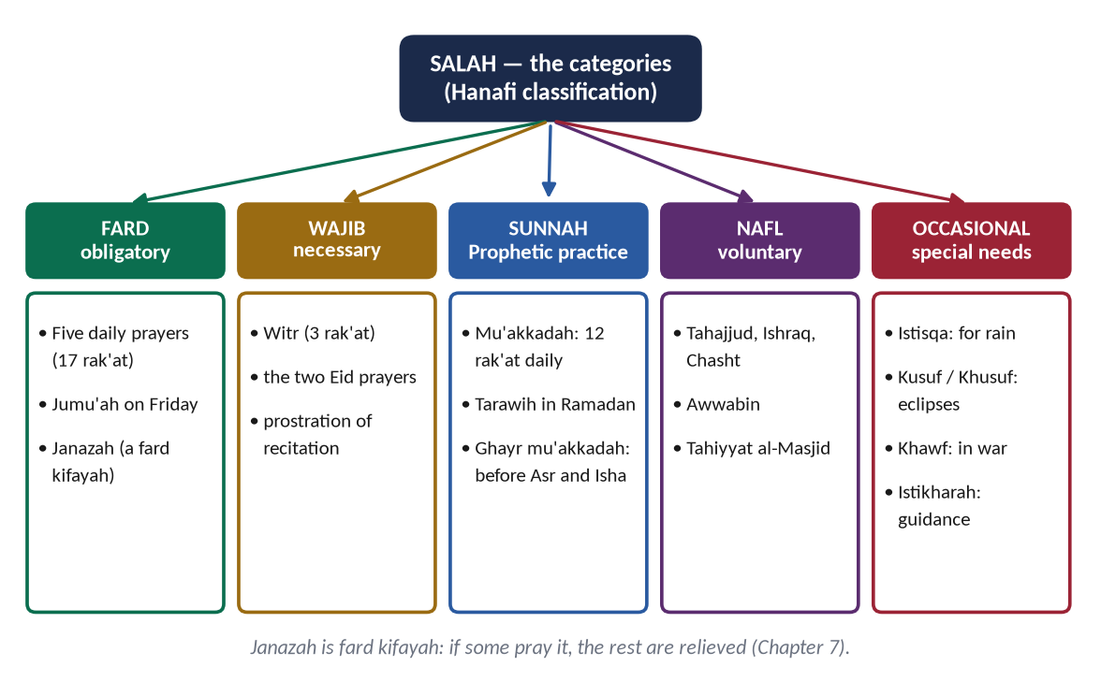
Figure 2 · The categories of Salah in the Hanafi classification.

(i) Fard — obligatory
- (a) The five daily prayers: Fajr 2, Zuhr 4, Asr 4, Maghrib 3, Isha 4 — 17 rak'at.
- (b) Jumu'ah — the Friday prayer with its sermon.
✦ QURAN
﴿يَـٰٓأَيُّهَا ٱلَّذِينَ ءَامَنُوٓاْ إِذَا نُودِيَ لِلصَّلَوٰةِ مِن يَوۡمِ ٱلۡجُمُعَةِ فَٱسۡعَوۡاْ إِلَىٰ ذِكۡرِ ٱللَّهِ وَذَرُواْ ٱلۡبَيۡعَۚ …﴾
“O you who believe, when the call is made for prayer on Friday, hasten to the remembrance of Allah and leave trade.” (Al-Jumu'ah, Quran)
➜ When the call is made for prayer on Friday, hasten to the remembrance of Allah and leave trade.

- (c) Janazah — the funeral prayer, a fard kifayah.

(ii) Wajib — necessary (Hanafi)
Witr after Isha; the two Eid prayers; the prostration of recitation.

(iii) Sunnah
- (a) Mu'akkadah: twelve daily rak'at (2 before Fajr, 4 before and 2 after Zuhr, 2 after Maghrib, 2 after Isha) and Tarawih in Ramadan.
- (b) Ghayr mu'akkadah: such as 4 before Asr and before Isha.

(iv) Nafl — voluntary
Tahajjud, Ishraq, Chasht (Duha), Awwabin, Tahiyyat al-Masjid.

(v) Prayers for special occasions
Istisqa (for rain), Kusuf and Khusuf (at eclipses), Salat al-Khawf (in war), Istikharah (for guidance).

(5) The spiritual impact of prayer

(i) Remembrance and nearness to Allah
✦ QURAN
﴿إِنَّنِيٓ أَنَا ٱللَّهُ لَآ إِلَٰهَ إِلَّآ أَنَا۠ فَٱعۡبُدۡنِي وَأَقِمِ ٱلصَّلَوٰةَ لِذِكۡرِيٓ﴾
“Indeed, I am Allah. There is no deity except Me, so worship Me and establish prayer for My remembrance.” (Taha, Quran)
➜ 'Establish prayer for My remembrance.'

(ii) Peace of heart
✦ QURAN
﴿إِنَّ ٱلۡإِنسَٰنَ خُلِقَ هَلُوعًا ۝ إِذَا مَسَّهُ ٱلشَّرُّ جَزُوعٗا ۝ وَإِذَا مَسَّهُ ٱلۡخَيۡرُ مَنُوعًا ۝ إِلَّا ٱلۡمُصَلِّينَ ۝ ٱلَّذِينَ هُمۡ عَلَىٰ صَلَاتِهِمۡ دَآئِمُونَ﴾
“Indeed, mankind was created anxious. When evil touches him, impatient. And when good touches him, withholding [of it]. Except the observers of prayer. Those who are constant in their prayer.” (Al-Ma'arij, Quran)
➜ Man was created anxious … except those who pray, who are constant in their prayer.

✦ HADITH
يَا بِلَالُ أَقِمِ الصَّلَاةَ، أَرِحْنَا بِهَا
“O Bilal, call the iqamah; give us rest through it.” (Abu Dawud)
➜ Prayer is rest for the soul.

(iii) Purification from sins
✦ HADITH
فَذَلِكَ مِثْلُ الصَّلَوَاتِ الْخَمْسِ، يَمْحُو اللَّهُ بِهِنَّ الْخَطَايَا
“That is the example of the five prayers: by them Allah wipes away sins.” (Al-Bukhari and Muslim)
➜ Said after the example of bathing five times a day in a river — daily spiritual cleansing.

(iv) Strength in trials
✦ QURAN
﴿وَٱسۡتَعِينُواْ بِٱلصَّبۡرِ وَٱلصَّلَوٰةِۚ وَإِنَّهَا لَكَبِيرَةٌ إِلَّا عَلَى ٱلۡخَٰشِعِينَ﴾
“And seek help through patience and prayer, and indeed, it is difficult except for the humbly submissive [to Allah].” (Al-Baqarah, Quran)
➜ 'Seek help through patience and prayer.'

(v) Khushu' — the soul of prayer
✦ QURAN
﴿قَدۡ أَفۡلَحَ ٱلۡمُؤۡمِنُونَ ۝ ٱلَّذِينَ هُمۡ فِي صَلَاتِهِمۡ خَٰشِعُونَ﴾
“Certainly will the believers have succeeded. They who are during their prayer humbly submissive.” (Al-Mu'minun, Quran)
➜ Successful are the believers who are humble in their prayers.

✦ SCHOLARLY VIEW
Imam Al-Ghazali · Ihya Ulum al-Din
Ghazali names six inner meanings that give life to prayer — presence of heart, understanding, reverence, awe, hope and shame before Allah — and warns that a prayer without them is a body without a soul.
➜ The spiritual impact depends on the heart, not on movements alone.

(6) The moral impact of prayer

(i) Restraint from evil
Al-Ankabut: prayer restrains from indecency and wrongdoing — the believer who stands before Allah five times a day is reminded five times a day of His limits.

(ii) Discipline and punctuality
Fixed times from dawn to night train a person to plan his life around duty.

(iii) Cleanliness
Wudu, clean clothes and a clean place — physical purity as a moral habit.

(iv) Humility
Placing the forehead on the ground breaks arrogance.

(v) Constant correction
✦ QURAN
﴿وَأَقِمِ ٱلصَّلَوٰةَ طَرَفَيِ ٱلنَّهَارِ وَزُلَفٗا مِّنَ ٱلَّيۡلِۚ إِنَّ ٱلۡحَسَنَٰتِ يُذۡهِبۡنَ ٱلسَّيِّـَٔاتِۚ ذَٰلِكَ ذِكۡرَىٰ لِلذَّـٰكِرِينَ﴾
“And establish prayer at the two ends of the day and at the approach of the night. Indeed, good deeds do away with misdeeds. That is a reminder for those who remember.” (Hud, Quran)
➜ Establish prayer at the two ends of the day and in the hours of the night; good deeds remove evil deeds.

(7) The social impact of prayer

(i) Equality and brotherhood
In the row, the rich and the poor, the officer and the labourer stand shoulder to shoulder.
✦ SCHOLARLY VIEW
Allama Muhammad Iqbal · Bang-e-Dara (Shikwa)
'Aik hi saf mein kharay ho gaye Mahmood-o-Ayaz, na koi banda raha aur na koi banda nawaz' — in one row of prayer Sultan Mahmud and his slave Ayaz stood together; no one remained a servant, no one a master.
➜ The social equality of Salah.

(ii) Unity and discipline of the community
✦ HADITH
صَلَاةُ الْجَمَاعَةِ أَفْضَلُ مِنْ صَلَاةِ الْفَذِّ بِسَبْعٍ وَعِشْرِينَ دَرَجَةً
“Prayer in congregation is twenty-seven degrees better than prayer alone.” (Al-Bukhari and Muslim)
➜ Islam rewards togetherness; the congregation trains obedience to lawful leadership.

(iii) The mosque as a centre of community life
The Prophet's mosque was a school, court, council hall and welfare centre; the daily meeting of neighbours keeps the community aware of each other's needs.

(iv) Jumu'ah — the weekly assembly
The Friday sermon addresses moral, social and national issues every week.

(v) Social order
The adhan organises the day; a praying society is punctual, clean and disciplined.
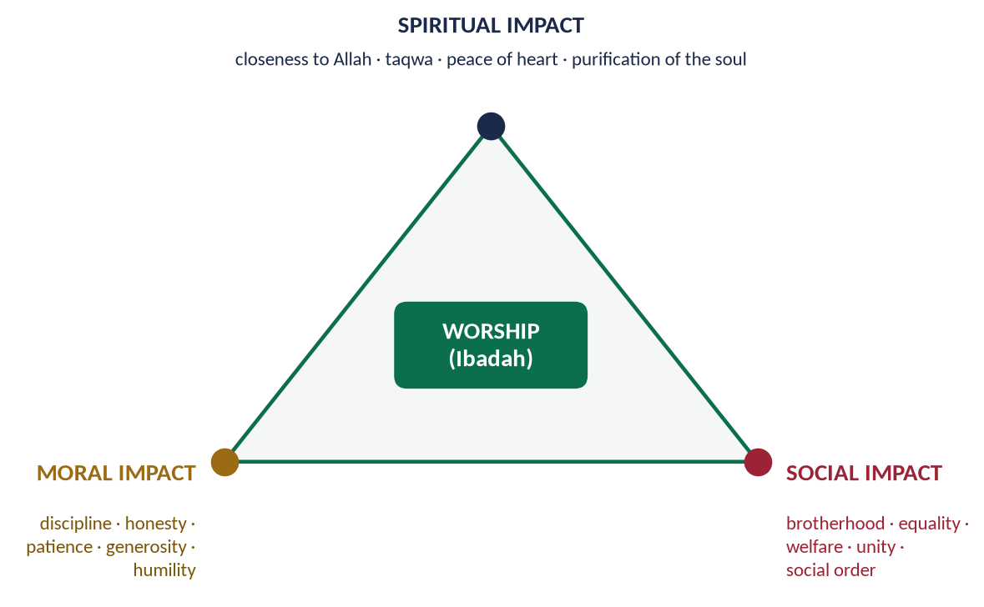
Figure 3 · The three impacts of prayer: spiritual, moral and social.
PAKISTAN ANGLE · THE GAP AND ITS REMEDY
Mosques are full, yet dishonesty persists. The Quran foresaw this: 'Woe to those who pray but are heedless of their prayer' (Al-Ma'un). The remedy is prayer with understanding and khushu' — teaching the meaning of what is recited — as Article 31 asks the state to promote the teaching of the Quran and the Islamic way of life.

(8) A misconception answered: 'Prayer is only a ritual — being a good person is enough'

(i) The claim
Some argue that what matters is good character, and that ritual prayer is an empty formality.

(ii) The answer
- (a) In Islam the two are not alternatives: prayer is the school of good character. The Quran itself says prayer 'restrains from indecency and wrongdoing' (Al-Ankabut).
- (b) The Prophet ﷺ — the model of character — prayed more than anyone, and called prayer 'the delight of my eyes'.
✦ HADITH
وَجُعِلَتْ قُرَّةُ عَيْنِي فِي الصَّلَاةِ
“And the delight of my eyes has been placed in prayer.” (Al-Nasa'i)
➜ The best of characters found his strength and joy in prayer.

- (c) Where prayer fails to reform, the fault is in its quality, not its existence — 'woe to those who are heedless of their prayer' (Al-Ma'un).

(iii) The Friday prayer as moral education
Every week the khutbah reminds the community of justice, honesty, rights of neighbours and duties to the state — prayer is linked to public morality by design.

(9) Conclusion
Salah is connection with Allah (its meaning), organised in a graded system from the obligatory to the voluntary (its categories), which purifies the soul, disciplines the character and binds society in equality and brotherhood (its impacts). When prayer loses its spirit it becomes a habit of the body; when it keeps its spirit it transforms the person and the nation.
✦ QURAN
﴿فَوَيۡلٞ لِّلۡمُصَلِّينَ ۝ ٱلَّذِينَ هُمۡ عَن صَلَاتِهِمۡ سَاهُونَ﴾
“So woe to those who pray. [But] who are heedless of their prayer.” (Al-Ma'un, Quran)
➜ 'Woe to those who pray, who are heedless of their prayer' — the Quran's own warning that prayer's power lies in its spirit.

Why this answer scores
- All five limbs have their own headings in the question's order; the impacts carry the most weight.
- The categories are given as a classification with a figure, not as a description of how to pray.
- Evidence is inside every point; Iqbal and Ghazali give depth; the Pakistan angle is honest.

Answer 2 · The Importance of Zakat and Economic Stability (CSS 2015)
THE QUESTION · CSS 2015 · Q5 · 16 marks (old scheme)
Highlight the importance of Zakat and prove that economic stability of a society can be ensured through its effective implementation.

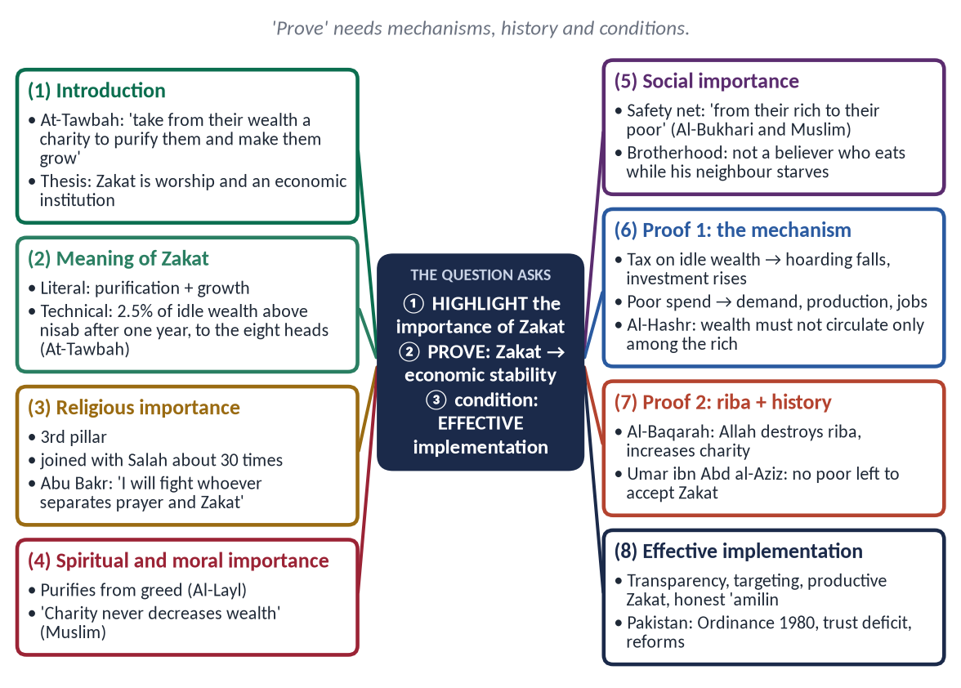
Figure 4 · The answer map: every branch is one numbered heading of the model answer below.

Decoding the question
- 'Highlight the importance' — religious, spiritual, moral and social importance, briefly but clearly (about 35%).
- 'Prove that economic stability … can be ensured' — the core (about 45%): show the economic mechanisms, support them with history and an economist's authority.
- 'Through its effective implementation' — the condition (about 20%): what makes Zakat effective, and why it has not worked well everywhere, including Pakistan.

The model answer

(1) Introduction
✦ QURAN
﴿خُذۡ مِنۡ أَمۡوَٰلِهِمۡ صَدَقَةٗ تُطَهِّرُهُمۡ وَتُزَكِّيهِم بِهَا …﴾
“Take from their wealth a charity by which you purify them and cause them to grow.” (At-Tawbah, Quran)
➜ 'Take from their wealth a charity by which you purify them and cause them to grow.'

Zakat is at once an act of worship and an economic institution. As worship it purifies the soul; as an institution it moves wealth every year from those who have more than they need to those who have less than they need. This answer highlights the importance of Zakat, then proves — by its economic mechanisms, by the ban on riba that accompanies it, and by history — that an effectively implemented Zakat ensures the economic stability of a society.

(2) The meaning of Zakat
- (a) Literal: purification and growth.
- (b) Technical: a fixed share (2.5%) of zakatable wealth above the nisab (7.5 tola gold / 52.5 tola silver), owned for a lunar year, given to the eight heads named in At-Tawbah.

(3) The importance of Zakat

(i) Religious importance
- (a) The third pillar of Islam; joined with Salah about thirty times in the Quran ('establish prayer and give Zakat', Al-Baqarah).
- (b) Defended as the right of society by the first Caliph:
✦ HADITH
وَاللَّهِ لَأُقَاتِلَنَّ مَنْ فَرَّقَ بَيْنَ الصَّلَاةِ وَالزَّكَاةِ
“By Allah, I will fight whoever separates prayer from Zakat.” (Al-Bukhari and Muslim)
➜ Zakat is not optional charity but a pillar of the Islamic order.

(ii) Spiritual and moral importance
✦ QURAN
﴿ٱلَّذِي يُؤۡتِي مَالَهُۥ يَتَزَكَّىٰ﴾
“[He] who gives [from] his wealth to purify himself.” (Al-Layl, Quran)
➜ The righteous one gives his wealth to purify himself.

✦ HADITH
مَا نَقَصَتْ صَدَقَةٌ مِنْ مَالٍ
“Charity never decreases wealth.” (Muslim)
➜ Zakat cures greed and brings barakah.

(iii) Social importance
✦ HADITH
تُؤْخَذُ مِنْ أَغْنِيَائِهِمْ فَتُرَدُّ عَلَى فُقَرَائِهِمْ
“It is taken from their rich and returned to their poor.” (Al-Bukhari and Muslim)
➜ A safety net built into every community.

✦ HADITH
لَيْسَ الْمُؤْمِنُ الَّذِي يَشْبَعُ وَجَارُهُ جَائِعٌ إِلَى جَنْبِهِ
“He is not a believer who eats his fill while his neighbour beside him is hungry.” (Al-Bayhaqi)
➜ Social solidarity is part of faith.

(4) Proof: how Zakat ensures economic stability
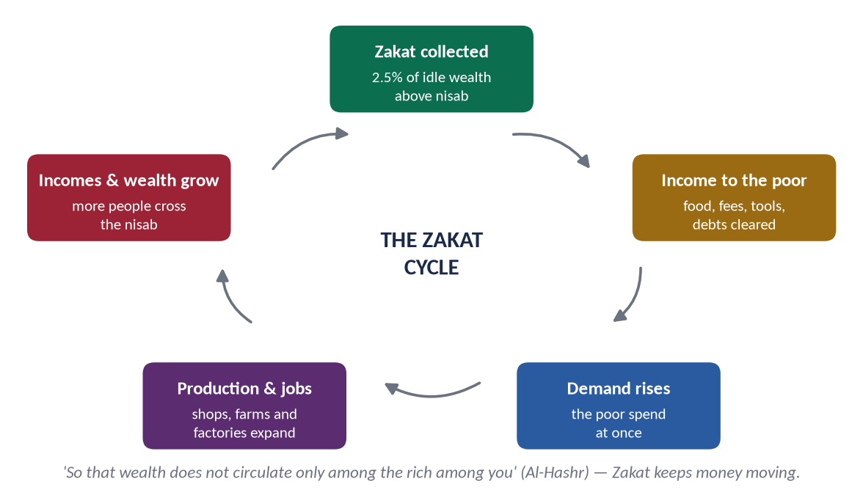
Figure 5 · The Zakat cycle: from idle wealth to demand, jobs and growth.

(i) It fights hoarding and pushes wealth into investment
Zakat is charged on idle wealth. Money kept unused shrinks by 2.5% a year, so owners are pushed to invest it in trade and production.
✦ QURAN
﴿… وَٱلَّذِينَ يَكۡنِزُونَ ٱلذَّهَبَ وَٱلۡفِضَّةَ وَلَا يُنفِقُونَهَا فِي سَبِيلِ ٱللَّهِ فَبَشِّرۡهُم بِعَذَابٍ أَلِيمٖ﴾
“And those who hoard gold and silver and do not spend it in the way of Allah — give them tidings of a painful punishment.” (At-Tawbah, Quran)
➜ Those who hoard gold and silver and do not spend it in the way of Allah — give them news of a painful punishment.

(ii) It keeps demand alive
The poor spend what they receive at once on food, clothes and needs. This steady demand keeps shops, farms and factories working even in slow times — a built-in stabiliser.

(iii) It creates employment
New demand and new investment create jobs; unemployment — the main cause of poverty and unrest — falls.

(iv) It reduces inequality
An annual transfer from rich to poor narrows the gap between classes and prevents the extreme inequality that fuels economic and political crises.
✦ QURAN
﴿… كَيۡ لَا يَكُونَ دُولَةَۢ بَيۡنَ ٱلۡأَغۡنِيَآءِ مِنكُمۡۚ …﴾
“… so that it does not circulate only among the rich among you.” (Al-Hashr, Quran)
➜ '… so that it does not circulate only among the rich among you.'

(v) It works together with the prohibition of riba
Zakat penalises idle money; the ban on riba closes the road of earning without risk. Together they direct wealth to real, productive activity.
✦ QURAN
﴿يَمۡحَقُ ٱللَّهُ ٱلرِّبَوٰاْ وَيُرۡبِي ٱلصَّدَقَٰتِۗ وَٱللَّهُ لَا يُحِبُّ كُلَّ كَفَّارٍ أَثِيمٍ﴾
“Allah destroys interest and gives increase for charities. And Allah does not like every sinning disbeliever.” (Al-Baqarah, Quran)
➜ 'Allah destroys riba and gives increase for charities.'

(vi) It builds social peace — the precondition of stability
Poverty and envy breed crime and unrest, which destroy investment. Zakat builds the trust and peace in which economies grow.

(vii) The proof of history
Historians report that under Umar ibn Abd al-Aziz (717–720 CE), Zakat officials in some provinces could find no one poor enough to accept Zakat — an effectively organised Zakat had transformed society within a few years.

(viii) The authority of economics
✦ SCHOLARLY VIEW
M. Umer Chapra · Islam and the Economic Challenge (FPSC reading list)
Chapra argues that the goals of the Islamic economy — need-fulfilment, full employment and an equitable distribution of income and wealth — are served by institutions such as Zakat together with the prohibition of interest, within a market economy.
➜ A leading economist supports the stability argument.

(5) The condition: effective implementation

(i) Why Zakat has not always delivered
Where Zakat is collected narrowly, distributed without transparency or used for consumption only, its economic power is lost.

(ii) The Pakistani experience
The Zakat and Ushr Ordinance, 1980 introduced deduction at source on the first of Ramadan from bank savings; many citizens opt out by declaration and give privately because of a trust deficit; after the 18th Amendment the subject passed to the provinces.

(iii) What effective implementation requires
- (a) Transparency: digital records, public accounts, independent audits.
- (b) Targeting: use the national socio-economic registry to reach the truly deserving.
- (c) Productive Zakat: grants for tools, small businesses and skills, and interest-free loans (Qard Hasan) on the model of successful Pakistani microfinance trusts.
- (d) Full assessment: all zakatable wealth, not only bank deposits.
- (e) Honest 'amilin: trained, accountable officials — the Quran's own third head.
PAKISTAN ANGLE
With about two-fifths of the population below the World Bank's poverty line (2024 estimate), an effective Zakat — alongside Article 31's call to organise Zakat and Ushr and Article 38's call to eliminate riba — is a constitutional as well as a religious duty.

(6) Objections answered

(i) 'Two and a half per cent is too little to stabilise an economy'
Zakat is charged on accumulated wealth every year, not on income; it is joined by Ushr, Sadaqat al-Fitr, Qurbani, voluntary Sadaqah and Waqf, and it works together with the ban on riba. It is the floor of Islamic welfare, not its ceiling.

(ii) 'Charity makes people dependent'
Islam aims at self-reliance: 'the upper hand is better than the lower hand' (Al-Bukhari and Muslim); Hazrat Umar's rule was to give enough to make the poor free of need; productive Zakat and Qard Hasan turn receivers into earners.

(iii) 'Zakat belongs to private conscience, not to the state'
The Quran names 'amilin — administrators — as a head of Zakat; the Prophet ﷺ appointed collectors and the Caliphs ran the Bait-ul-Mal. Effective Zakat is an organised public institution.
Point | Zakat | Modern social security
Basis | Divine command; worship | Legislation and budgets
Stability | Fixed rates and recipients | Changes with governments
Spirit | The poor's right; dignity | Often bureaucratic

(7) Conclusion
Zakat is important because it is a pillar of faith, a purifier of the soul and a guarantor of the poor. It ensures economic stability because it turns idle wealth into investment, keeps demand alive, creates jobs, narrows inequality and builds social peace — as the reign of Umar ibn Abd al-Aziz showed. Its power, however, depends on effective implementation: transparent, well-targeted and productive.
✦ QURAN
﴿مَّثَلُ ٱلَّذِينَ يُنفِقُونَ أَمۡوَٰلَهُمۡ فِي سَبِيلِ ٱللَّهِ كَمَثَلِ حَبَّةٍ أَنۢبَتَتۡ سَبۡعَ سَنَابِلَ فِي كُلِّ سُنۢبُلَةٖ مِّاْئَةُ حَبَّةٖۗ وَٱللَّهُ يُضَٰعِفُ لِمَن يَشَآءُۚ وَٱللَّهُ وَٰسِعٌ عَلِيمٌ﴾
“The example of those who spend their wealth in the way of Allah is like a seed [of grain] which grows seven spikes; in each spike is a hundred grains. And Allah multiplies [His reward] for whom He wills. And Allah is all-Encompassing and Knowing.” (Al-Baqarah, Quran)
➜ The example of those who spend in the way of Allah is like a grain that grows seven ears, in each ear a hundred grains — Zakat multiplies, in reward and in the economy.

Why this answer scores
- 'Prove' is met with a chain of mechanisms, a figure, history and an economist.
- The condition in the question ('effective implementation') has its own section, with Pakistan's experience.
- Importance is covered briefly but completely — religious, spiritual, moral, social.

Answer 3 · The Recipients of Zakat, Its Social Impact and Poverty Alleviation (CSS 2017)
THE QUESTION · CSS 2017 · Q2 · 20 marks
Who are entitled to receive Zakat according to the Quran? Elucidating social impact of Zakat, clarify how can poverty be alleviated with its distribution in Islamic Society?

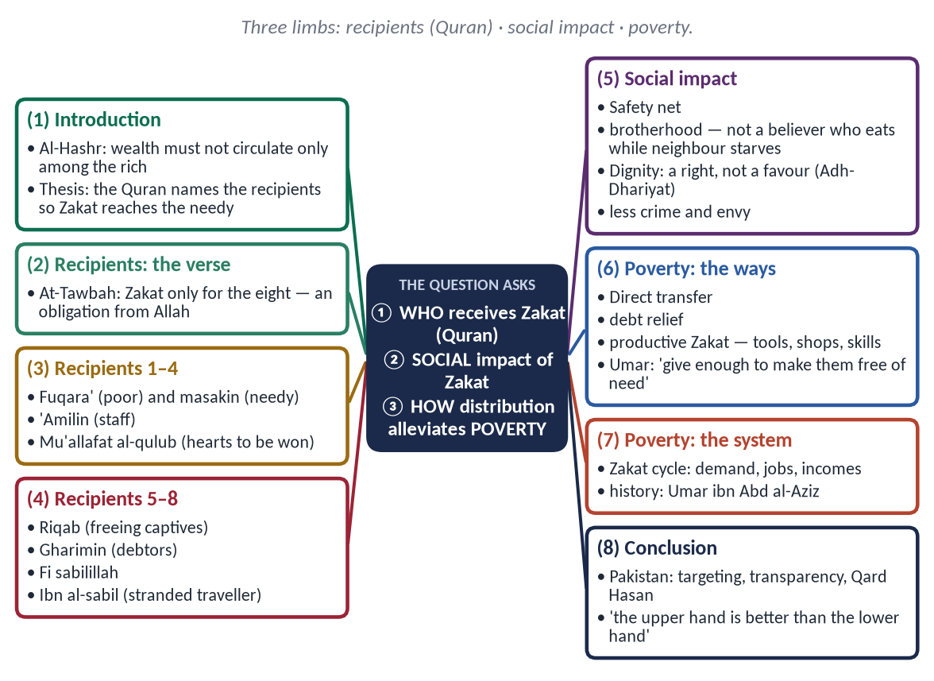
Figure 6 · The answer map: every branch is one numbered heading of the model answer below.

Decoding the question
- 'Who are entitled … according to the Quran?' — the eight heads of At-Tawbah, each explained. This is the backbone; quote the verse.
- 'Elucidating social impact' — a middle section on how Zakat shapes society.
- 'Clarify how poverty can be alleviated with its distribution' — the practical section: mechanisms and a plan.

The model answer

(1) Introduction
✦ QURAN
﴿… كَيۡ لَا يَكُونَ دُولَةَۢ بَيۡنَ ٱلۡأَغۡنِيَآءِ مِنكُمۡۚ …﴾
“… so that it does not circulate only among the rich among you.” (Al-Hashr, Quran)
➜ '… so that it does not circulate only among the rich among you.'

The Quran does not leave Zakat to the choice of the giver; it names the very people who are entitled to it. This is why Zakat reaches the needy and does not become a favour to friends or a fund for the powerful. This answer sets out the recipients of Zakat according to the Quran, elucidates its social impact, and explains how its distribution can alleviate poverty in an Islamic society.

(2) Who is entitled to receive Zakat — the Quranic text
✦ QURAN
﴿إِنَّمَا ٱلصَّدَقَٰتُ لِلۡفُقَرَآءِ وَٱلۡمَسَٰكِينِ وَٱلۡعَٰمِلِينَ عَلَيۡهَا وَٱلۡمُؤَلَّفَةِ قُلُوبُهُمۡ وَفِي ٱلرِّقَابِ وَٱلۡغَٰرِمِينَ وَفِي سَبِيلِ ٱللَّهِ وَٱبۡنِ ٱلسَّبِيلِۖ فَرِيضَةٗ مِّنَ ٱللَّهِۗ وَٱللَّهُ عَلِيمٌ حَكِيمٞ﴾
“Zakah expenditures are only for the poor and for the needy and for those employed to collect [zakah] and for bringing hearts together [for Islam] and for freeing captives [or slaves] and for those in debt and for the cause of Allah and for the [stranded] traveler - an obligation [imposed] by Allah. And Allah is Knowing and Wise.” (At-Tawbah, Quran)
➜ Zakat is only for the poor, the needy, those employed to collect it, those whose hearts are to be reconciled, freeing captives, debtors, in the cause of Allah, and the traveller — an obligation from Allah.

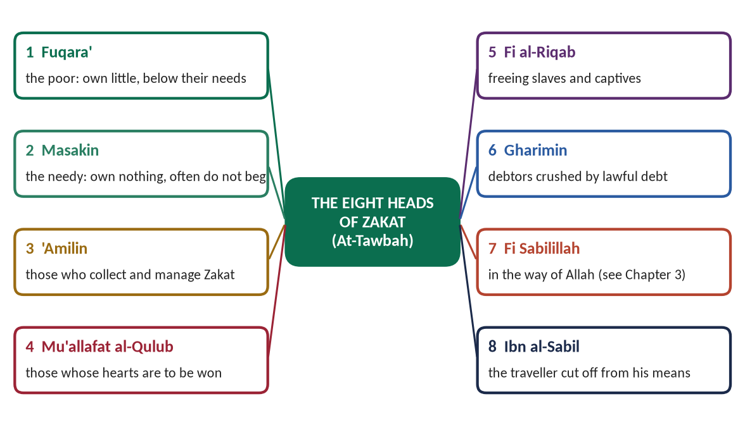
Figure 7 · The eight heads of Zakat.

(i) Al-Fuqara' — the poor
Those who own something but less than their needs, below the nisab.

(ii) Al-Masakin — the needy
Those who own nothing and are in greater need; many do not beg out of self-respect (in the Hanafi view, poorer than the faqir).

(iii) Al-'Amilin 'alayha — those employed to administer it
Collectors, accountants and distributors, paid from Zakat even if they are not poor — which shows that Zakat is an organised institution.

(iv) Al-Mu'allafat al-Qulub — those whose hearts are to be won
New Muslims or people whose support benefits the community. Hazrat Umar (RA) stopped this share when Islam had become strong; the Hanafis regard it as lapsed, while others keep it for times of need.

(v) Fi al-Riqab — freeing slaves and captives
Buying freedom for the enslaved; modern scholars apply its spirit to freeing captives and victims of bonded labour.

(vi) Al-Gharimin — debtors
Those crushed by lawful debts they cannot repay.

(vii) Fi Sabilillah — in the way of Allah
Classically, those striving in Jihad who lack means; some jurists extend it to pilgrims and students of religious knowledge.

(viii) Ibn al-Sabil — the traveller
A traveller cut off from his wealth, even if rich at home.

(ix) Who may not receive it
The rich; one's own parents, children and spouse, whose support is already a duty. Under the Hanafi rule of tamlik, Zakat must be given into the ownership of the recipient.

(3) The social impact of Zakat

(i) A social safety net
✦ HADITH
تُؤْخَذُ مِنْ أَغْنِيَائِهِمْ فَتُرَدُّ عَلَى فُقَرَائِهِمْ
“It is taken from their rich and returned to their poor.” (Al-Bukhari and Muslim)
➜ Every community carries its own welfare system.

(ii) Brotherhood and social cohesion
✦ HADITH
لَيْسَ الْمُؤْمِنُ الَّذِي يَشْبَعُ وَجَارُهُ جَائِعٌ إِلَى جَنْبِهِ
“He is not a believer who eats his fill while his neighbour beside him is hungry.” (Al-Bayhaqi)
➜ Zakat turns neighbours into brothers.

(iii) Dignity of the poor
✦ QURAN
﴿وَفِيٓ أَمۡوَٰلِهِمۡ حَقّٞ لِّلسَّآئِلِ وَٱلۡمَحۡرُومِ﴾
“And from their properties was [given] the right of the [needy] petitioner and the deprived.” (Adh-Dhariyat, Quran)
➜ In their wealth was a right for the one who asks and the one who is deprived — the poor receive a right, not a favour.

(iv) Reduction of envy, class hatred and crime
When the rich share, the poor do not envy; the root of much crime — want — is removed.

(v) A moral society
The giver learns generosity, the receiver gratitude; greed and miserliness lose their hold.

(4) How poverty can be alleviated through the distribution of Zakat

(i) Direct transfer to the poorest
By law, Zakat goes first to the poor and needy — no leakage to other purposes.

(ii) Freeing families from debt
The share of the gharimin breaks the cycle of debt and interest that keeps families poor.

(iii) Productive Zakat: from receiver to earner
✦ SCHOLARLY VIEW
Hazrat Umar Farooq (RA) · the second Caliph
Hazrat Umar is reported to have told his officials that when they give, they should give enough to make the recipient free of need.
➜ Zakat should end dependence, not manage it.

Zakat can buy a rickshaw, a sewing machine, livestock or a stall; fund skills training; or support interest-free loans (Qard Hasan), so that a family leaves the Zakat list and one day pays Zakat itself.
✦ HADITH
الْيَدُ الْعُلْيَا خَيْرٌ مِنَ الْيَدِ السُّفْلَى
“The upper hand (that gives) is better than the lower hand (that takes).” (Al-Bukhari and Muslim)
➜ The goal is to turn receivers into givers.

(iv) Education and health
Fees for poor students and treatment for poor patients build the human capital that ends poverty in the next generation.

(v) The multiplier effect
Money given to the poor is spent at once; it raises demand, production and jobs, lifting incomes across the community (the Zakat cycle).

(vi) The proof of history
Under Umar ibn Abd al-Aziz (717–720 CE), Zakat officials in some provinces reportedly found no one poor enough to accept Zakat.

(vii) A plan for Pakistan
- (a) Accurate targeting through the national socio-economic registry.
- (b) Transparent, audited, digital distribution to rebuild trust.
- (c) A fixed share for productive Zakat and Qard Hasan.
- (d) Coordination of state Zakat, welfare trusts and mosques.
- (e) Honest, trained 'amilin.
PAKISTAN ANGLE
About two-fifths of Pakistanis live below the World Bank's poverty line (2024 estimate). Private Zakat already sustains hospitals, schools and microfinance trusts; organising it transparently and productively could make it the backbone of social protection.

(5) The conditions that make distribution effective

(i) Priority to the neediest
The Quran lists the poor and the needy first; local needs are met before Zakat is moved elsewhere — the instruction given to Mu'adh (RA): 'taken from their rich and returned to their poor'.

(ii) Justice to the payer as well
✦ HADITH
فَإِيَّاكَ وَكَرَائِمَ أَمْوَالِهِمْ، وَاتَّقِ دَعْوَةَ الْمَظْلُومِ، فَإِنَّهُ لَيْسَ بَيْنَهَا وَبَيْنَ اللَّهِ حِجَابٌ
“Avoid taking the best of their wealth, and fear the supplication of the oppressed, for there is no barrier between it and Allah.” (Al-Bukhari and Muslim)
➜ An honest system is fair to both sides — the basis of public trust.

(iii) Dignity in giving
Zakat is the poor man's right; it must be given without humiliation or publicity.
✦ QURAN
﴿… لَا تُبۡطِلُواْ صَدَقَٰتِكُم بِٱلۡمَنِّ وَٱلۡأَذَىٰ …﴾
“Do not invalidate your charities with reminders of generosity or injury.” (Al-Baqarah, Quran)
➜ 'Do not invalidate your charities with reminders of generosity or injury' — dignity is part of the law of giving.

(6) Conclusion
The Quran itself names the eight classes entitled to Zakat, so that the wealth of the rich reaches the poor, the indebted, the stranded and the oppressed. Its social impact is a society of brotherhood, dignity and trust; and its distribution — direct, productive and well-organised — can lift families out of poverty and, as history shows, can even end it.
✦ QURAN
﴿مَّثَلُ ٱلَّذِينَ يُنفِقُونَ أَمۡوَٰلَهُمۡ فِي سَبِيلِ ٱللَّهِ كَمَثَلِ حَبَّةٍ أَنۢبَتَتۡ سَبۡعَ سَنَابِلَ فِي كُلِّ سُنۢبُلَةٖ مِّاْئَةُ حَبَّةٖۗ وَٱللَّهُ يُضَٰعِفُ لِمَن يَشَآءُۚ وَٱللَّهُ وَٰسِعٌ عَلِيمٌ﴾
“The example of those who spend their wealth in the way of Allah is like a seed [of grain] which grows seven spikes; in each spike is a hundred grains. And Allah multiplies [His reward] for whom He wills. And Allah is all-Encompassing and Knowing.” (Al-Baqarah, Quran)
➜ Spending in the way of Allah is like a grain that grows seven ears — Zakat multiplies, in reward and in welfare.

Why this answer scores
- The recipients are given from the Quran, as asked: the verse first, then all eight heads, then who is excluded.
- Social impact and poverty alleviation have separate sections, as the question's two verbs demand.
- A practical plan for Pakistan turns theory into application.

Answer 4 · The Zakat System and Its Spiritual, Moral and Social Impacts (CSS 2018)
THE QUESTION · CSS 2018 · Q6 · 20 marks
Write a comprehensive note on Zakat system of Islam and its spiritual, moral and social impacts.

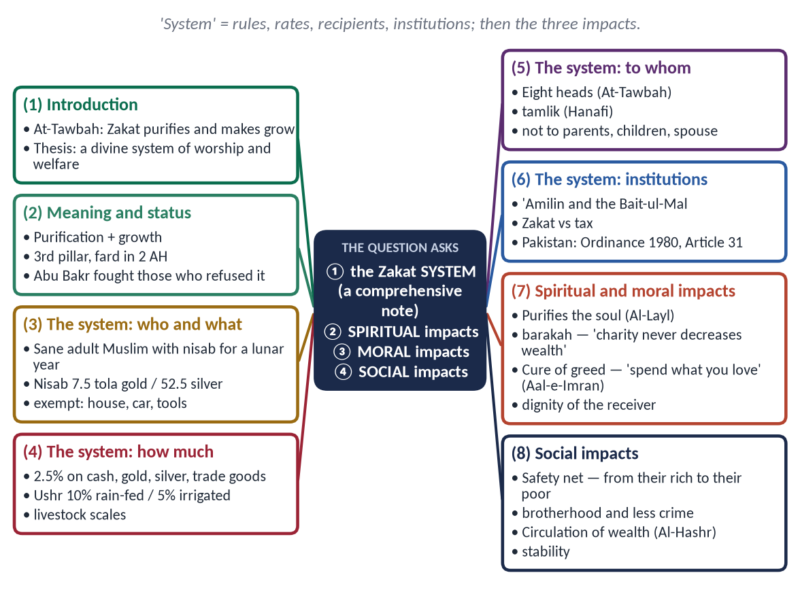
Figure 8 · The answer map: every branch is one numbered heading of the model answer below.

Decoding the question
- 'A comprehensive note on the Zakat system' — the examiner wants the machinery: who pays, on what, how much, to whom, and through which institutions. This is roughly half the answer.
- 'Its spiritual, moral and social impacts' — three headed sections, each with 3–5 points and evidence.

The model answer

(1) Introduction
✦ QURAN
﴿خُذۡ مِنۡ أَمۡوَٰلِهِمۡ صَدَقَةٗ تُطَهِّرُهُمۡ وَتُزَكِّيهِم بِهَا …﴾
“Take from their wealth a charity by which you purify them and cause them to grow.” (At-Tawbah, Quran)
➜ 'Take from their wealth a charity by which you purify them and cause them to grow, and invoke blessings upon them.'

Zakat is not merely charity left to the mood of the rich. It is a system — with fixed rates, a fixed threshold, fixed recipients and an institution to collect and distribute it — laid down by Allah and organised by the Prophet ﷺ in the state of Madinah. This note describes the Zakat system of Islam and then its spiritual, moral and social impacts.

(2) The meaning and status of Zakat

(i) Meaning
Literally purification and growth; technically, a fixed share of zakatable wealth above the nisab, owned for a lunar year, given to the specified recipients.

(ii) Status
- (a) The third pillar of Islam; joined with Salah about thirty times in the Quran.
- (b) Made obligatory in 2 AH in Madinah.
- (c) Treated as the right of society by the first Caliph:
✦ HADITH
وَاللَّهِ لَأُقَاتِلَنَّ مَنْ فَرَّقَ بَيْنَ الصَّلَاةِ وَالزَّكَاةِ
“By Allah, I will fight whoever separates prayer from Zakat.” (Al-Bukhari and Muslim)
➜ Zakat is a pillar of the social order, not a private option.

(3) The Zakat system

(i) Who must pay
A sane, adult, free Muslim who owns the nisab, free of debt, for a full lunar year (hawl).

(ii) The nisab
- Gold: 7.5 tola (about 87.48 g). Silver: 52.5 tola (about 612.36 g).
- For cash and trade goods the Hanafis use the silver nisab — lower, and so kinder to the poor.

(iii) The rates
Wealth | Rate | Note
Cash, savings, gold, silver, trade goods | 2.5% | On idle wealth held for a year
Agricultural produce (Ushr) | 10% or 5% | 10% rain-fed; 5% artificially irrigated
Livestock | fixed scales | Camels, cattle, sheep, goats above set numbers

(iv) What is exempt
One's house, personal vehicle, clothes, household goods and tools of trade — wealth in use, not idle wealth.

(v) The recipients
✦ QURAN
﴿إِنَّمَا ٱلصَّدَقَٰتُ لِلۡفُقَرَآءِ وَٱلۡمَسَٰكِينِ وَٱلۡعَٰمِلِينَ عَلَيۡهَا وَٱلۡمُؤَلَّفَةِ قُلُوبُهُمۡ وَفِي ٱلرِّقَابِ وَٱلۡغَٰرِمِينَ وَفِي سَبِيلِ ٱللَّهِ وَٱبۡنِ ٱلسَّبِيلِۖ فَرِيضَةٗ مِّنَ ٱللَّهِۗ وَٱللَّهُ عَلِيمٌ حَكِيمٞ﴾
“Zakah expenditures are only for the poor and for the needy and for those employed to collect [zakah] and for bringing hearts together [for Islam] and for freeing captives [or slaves] and for those in debt and for the cause of Allah and for the [stranded] traveler - an obligation [imposed] by Allah. And Allah is Knowing and Wise.” (At-Tawbah, Quran)
➜ Zakat is only for the poor, the needy, its collectors, those whose hearts are to be won, freeing captives, debtors, in the cause of Allah, and the traveller.

Figure 9 · The eight heads of Zakat.
- (a) Tamlik: in the Hanafi school Zakat must be given into the ownership of an eligible person.
- (b) Excluded: the rich; one's parents, children and spouse.

(vi) The institution
The Prophet ﷺ appointed collectors ('amilin); the Caliphs developed the Bait-ul-Mal (public treasury). Zakat is therefore both personal worship and a public institution.

(vii) Zakat and tax
Point | Zakat | Tax
Nature | Worship; pillar of faith | Civil obligation
Law | Fixed by Allah | Changed by governments
Rate | Fixed | Variable
Recipients | Eight heads only | Any public spending
Motive | Allah's pleasure | Legal compulsion

(viii) Zakat in Pakistan
The Zakat and Ushr Ordinance, 1980 deducts Zakat at source on the first of Ramadan from savings above the nisab; exemption is possible by declaration; local Zakat committees distribute; since the 18th Amendment (2010) the subject is provincial; Article 31 asks the state to organise Zakat, Ushr, Auqaf and mosques.

(4) The spiritual impacts of Zakat

(i) Purification of the soul
✦ QURAN
﴿ٱلَّذِي يُؤۡتِي مَالَهُۥ يَتَزَكَّىٰ﴾
“[He] who gives [from] his wealth to purify himself.” (Al-Layl, Quran)
➜ The righteous one gives his wealth to purify himself.

(ii) Gratitude and trusteeship
The owner recognises that wealth belongs to Allah and is held in trust.

(iii) Blessing and reward
✦ HADITH
مَا نَقَصَتْ صَدَقَةٌ مِنْ مَالٍ
“Charity never decreases wealth.” (Muslim)
➜ Zakat brings barakah and multiplied reward (the seven ears of Al-Baqarah).

(5) The moral impacts of Zakat

(i) Cure of greed and miserliness
✦ QURAN
﴿لَن تَنَالُواْ ٱلۡبِرَّ حَتَّىٰ تُنفِقُواْ مِمَّا تُحِبُّونَۚ وَمَا تُنفِقُواْ مِن شَيۡءٖ فَإِنَّ ٱللَّهَ بِهِۦ عَلِيمٞ﴾
“Never will you attain the good [reward] until you spend [in the way of Allah] from that which you love. And whatever you spend - indeed, Allah is Knowing of it.” (Aal-e-Imran, Quran)
➜ You will never attain righteousness until you spend from that which you love.

(ii) Generosity and empathy
The giver learns to feel the needs of others.

(iii) Dignity of the receiver
✦ QURAN
﴿وَفِيٓ أَمۡوَٰلِهِمۡ حَقّٞ لِّلسَّآئِلِ وَٱلۡمَحۡرُومِ﴾
“And from their properties was [given] the right of the [needy] petitioner and the deprived.” (Adh-Dhariyat, Quran)
➜ In their wealth is a right for the one who asks and the deprived — the poor receive a right, not a favour.

(iv) Freedom from envy and hatred
Sharing removes the poor man's envy and the rich man's fear.

(6) The social impacts of Zakat

(i) A social safety net
✦ HADITH
تُؤْخَذُ مِنْ أَغْنِيَائِهِمْ فَتُرَدُّ عَلَى فُقَرَائِهِمْ
“It is taken from their rich and returned to their poor.” (Al-Bukhari and Muslim)
➜ A built-in welfare system in every community.

(ii) Brotherhood and cohesion
✦ HADITH
لَيْسَ الْمُؤْمِنُ الَّذِي يَشْبَعُ وَجَارُهُ جَائِعٌ إِلَى جَنْبِهِ
“He is not a believer who eats his fill while his neighbour beside him is hungry.” (Al-Bayhaqi)
➜ Faith demands social solidarity.

(iii) Circulation of wealth and reduced inequality
✦ QURAN
﴿… كَيۡ لَا يَكُونَ دُولَةَۢ بَيۡنَ ٱلۡأَغۡنِيَآءِ مِنكُمۡۚ …﴾
“… so that it does not circulate only among the rich among you.” (Al-Hashr, Quran)
➜ '… so that it does not circulate only among the rich among you.'

(iv) Less crime and more stability
Want breeds crime and unrest; Zakat removes the want, and with it much of the crime.

(v) Self-reliance
Productive Zakat — tools, trade, training — turns receivers into earners: 'the upper hand is better than the lower hand' (Al-Bukhari and Muslim).
Figure 10 · The spiritual, moral and social impacts of Zakat.

(7) Zakat in history — the system at work

(i) The Prophet ﷺ
Appointed collectors to the tribes, instructed them to take from the middle of the wealth and to fear the prayer of the oppressed, and distributed Zakat locally first.

(ii) The Rightly-Guided Caliphs
Abu Bakr (RA) defended Zakat as a pillar; Umar (RA) organised the Bait-ul-Mal and the registers (diwan) and gave stipends to the needy from public funds.

(iii) Umar ibn Abd al-Aziz
Under his honest rule, Zakat officials in some provinces reportedly found no one poor enough to accept it — the system at its best.

(iv) The lesson
The system is perfect; its results depend on the honesty of those who run it — which is why the Quran makes the 'amilin a head of Zakat and the Prophet ﷺ warned his collectors so strongly.

(8) Conclusion
Zakat is a complete divine system: a threshold that exempts the needy, a modest rate on idle wealth, eight named classes of recipients, and an institution to collect and distribute. Its impacts reach the soul (purification), the character (generosity and dignity) and society (welfare, brotherhood and stability). Organised honestly — as Article 31 of the Constitution requires — it remains the most complete social security system ever given to mankind.
✦ QURAN
﴿يَمۡحَقُ ٱللَّهُ ٱلرِّبَوٰاْ وَيُرۡبِي ٱلصَّدَقَٰتِۗ وَٱللَّهُ لَا يُحِبُّ كُلَّ كَفَّارٍ أَثِيمٍ﴾
“Allah destroys interest and gives increase for charities. And Allah does not like every sinning disbeliever.” (Al-Baqarah, Quran)
➜ 'Allah destroys riba and gives increase for charities.'

Why this answer scores
- 'System' is answered as a system — who, what, how much, to whom, through which institution — with two tables and a figure.
- The three impacts have separate headed sections with evidence in each.
- Pakistan's Zakat law and Article 31 give the note depth and relevance.

Answer 5 · The Hajj System and Its Spiritual, Moral and Social Impacts (CSS 2019)
THE QUESTION · CSS 2019 · Q6 · 20 marks
Write a comprehensive note on Hajj (the pilgrimage) system of Islam and its spiritual, moral and social impacts.

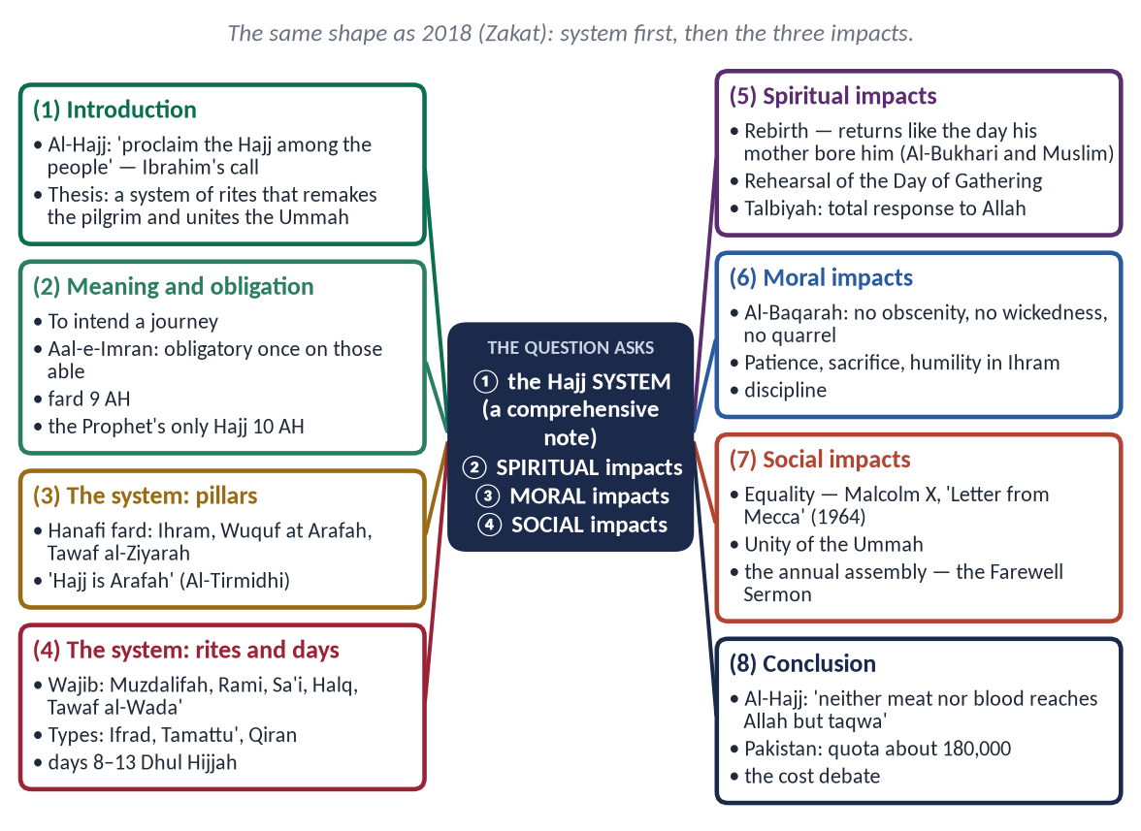
Figure 11 · The answer map: every branch is one numbered heading of the model answer below.

Decoding the question
- 'Hajj system' — meaning, obligation and conditions, pillars and obligatory rites, the types, and the order of the days. About half the answer.
- 'Spiritual, moral and social impacts' — three headed sections with evidence.

The model answer

(1) Introduction
✦ QURAN
﴿وَأَذِّن فِي ٱلنَّاسِ بِٱلۡحَجِّ يَأۡتُوكَ رِجَالٗا وَعَلَىٰ كُلِّ ضَامِرٖ يَأۡتِينَ مِن كُلِّ فَجٍّ عَمِيقٖ﴾
“And proclaim to the people the Hajj [pilgrimage]; they will come to you on foot and on every lean camel; they will come from every distant pass.” (Al-Hajj, Quran)
➜ 'Proclaim the Hajj among the people; they will come to you on foot and on every lean camel from every distant pass.'

Four thousand years ago, Ibrahim (AS) called mankind to the House he had built with his son. Every year since, the call has been answered. Hajj is the fifth pillar of Islam — a precise system of rites at fixed places and times, which remakes the pilgrim spiritually and morally and gathers the Ummah in a living demonstration of equality and unity. This note describes the Hajj system and its spiritual, moral and social impacts.

(2) Meaning and obligation

(i) Meaning
Literally to intend a journey; technically, the journey to the House of Allah in Dhul Hijjah to perform specific rites at specific places and times.

(ii) Obligation
✦ QURAN
﴿… وَلِلَّهِ عَلَى ٱلنَّاسِ حِجُّ ٱلۡبَيۡتِ مَنِ ٱسۡتَطَاعَ إِلَيۡهِ سَبِيلٗاۚ …﴾
“And [due] to Allah from the people is a pilgrimage to the House — for whoever is able to find a way to it.” (Aal-e-Imran, Quran)
➜ Pilgrimage to the House is a duty owed to Allah by those who are able to find a way to it.

- (a) Obligatory once in a lifetime on every adult Muslim who is able.
- (b) Made obligatory in 9 AH; Hazrat Abu Bakr (RA) led that year's Hajj.
- (c) The Prophet ﷺ performed his only Hajj in 10 AH and taught its rites:
✦ HADITH
لِتَأْخُذُوا مَنَاسِكَكُمْ، فَإِنِّي لَا أَدْرِي لَعَلِّي لَا أَحُجُّ بَعْدَ حَجَّتِي هَذِهِ
“Take your rites from me, for I do not know; perhaps I will not perform Hajj after this Hajj of mine.” (Muslim)
➜ The system of Hajj is fixed by the Sunnah.

(iii) Conditions (istita'ah)
Islam, sanity, adulthood, freedom, health, means for the journey and the family, a safe route — and, for a woman in the Hanafi school, a mahram.

(3) The Hajj system
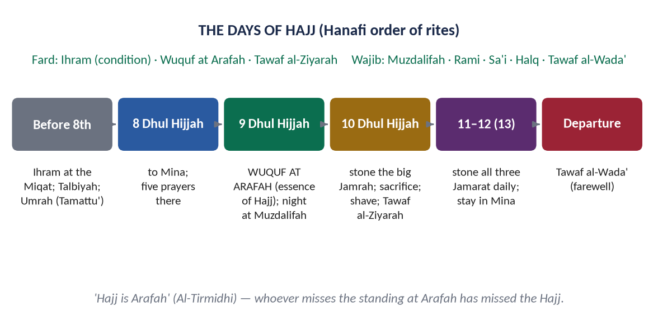
Figure 12 · The days and rites of Hajj.

(i) The Fard (Hanafi)
- (a) Ihram — intention and the sacred state.
- (b) Wuquf at Arafah — on the 9th of Dhul Hijjah; the essence of Hajj.
- (c) Tawaf al-Ziyarah — the circuit of the Ka'bah after Arafah.
✦ HADITH
الْحَجُّ عَرَفَةُ
“Hajj is Arafah.” (Al-Tirmidhi)
➜ Whoever misses Arafah has missed the Hajj.

(ii) The Wajibat (Hanafi)
Staying at Muzdalifah; Rami (stoning the Jamarat); Sa'i between Safa and Marwah; Halq or taqsir; Tawaf al-Wada'. A missed wajib requires a sacrifice.

(iii) The types
Ifrad (Hajj alone), Tamattu' (Umrah, then Hajj — the usual choice of Pakistani pilgrims), Qiran (both in one Ihram).

(iv) The days
8th: to Mina → 9th: Arafah, then Muzdalifah → 10th: stoning, sacrifice, shaving, Tawaf al-Ziyarah → 11th–13th: stoning the three Jamarat at Mina → the farewell Tawaf.

(v) The meaning behind the rites
Sa'i recalls Hajar (AS) searching for water; Rami recalls Ibrahim (AS) rejecting Satan; the sacrifice recalls his readiness to sacrifice his son; the Ka'bah was raised by Ibrahim and Isma'il (AS).
✦ QURAN
﴿لَن يَنَالَ ٱللَّهَ لُحُومُهَا وَلَا دِمَآؤُهَا وَلَٰكِن يَنَالُهُ ٱلتَّقۡوَىٰ مِنكُمۡۚ كَذَٰلِكَ سَخَّرَهَا لَكُمۡ لِتُكَبِّرُواْ ٱللَّهَ عَلَىٰ مَا هَدَىٰكُمۡۗ وَبَشِّرِ ٱلۡمُحۡسِنِينَ﴾
“Their meat will not reach Allah, nor will their blood, but what reaches Him is piety from you. Thus have We subjected them to you that you may glorify Allah for that [to] which He has guided you; and give good tidings to the doers of good.” (Al-Hajj, Quran)
➜ 'Neither their meat nor their blood reaches Allah, but what reaches Him is taqwa from you.'

(4) The spiritual impacts of Hajj

(i) Forgiveness and a new beginning
✦ HADITH
مَنْ حَجَّ لِلَّهِ فَلَمْ يَرْفُثْ وَلَمْ يَفْسُقْ رَجَعَ كَيَوْمِ وَلَدَتْهُ أُمُّهُ
“Whoever performs Hajj for Allah without obscenity or wickedness returns like the day his mother gave birth to him.” (Al-Bukhari and Muslim)
➜ Hajj is spiritual rebirth.

(ii) The reward of Paradise
✦ HADITH
الْحَجُّ الْمَبْرُورُ لَيْسَ لَهُ جَزَاءٌ إِلَّا الْجَنَّةُ
“An accepted Hajj has no reward except Paradise.” (Al-Bukhari and Muslim)
➜ The highest spiritual reward is attached to a sincere Hajj.

(iii) A rehearsal of the Day of Judgement
Millions in white, bareheaded under the sun of Arafah — a living picture of the Gathering, which strengthens belief in the Akhirah.

(iv) Total surrender
The Talbiyah — 'Here I am, O Allah, here I am' — is the language of complete response to Allah's call.

(5) The moral impacts of Hajj

(i) Self-control
✦ QURAN
﴿… فَلَا رَفَثَ وَلَا فُسُوقَ وَلَا جِدَالَ فِي ٱلۡحَجِّۗ …﴾
“There is to be no obscenity, no wickedness and no quarrelling during Hajj.” (Al-Baqarah, Quran)
➜ In Hajj there is no obscenity, no wickedness, and no quarrelling.

(ii) Patience and sacrifice
Heat, crowds and hardship teach patience; money, time and comfort are given up for Allah.

(iii) Humility
Two white sheets remove every sign of rank, wealth and nation.

(iv) Discipline
Every rite at its time and place; millions move to one timetable.

(6) The social impacts of Hajj

(i) The equality of mankind
✦ SCHOLARLY VIEW
Malcolm X (El-Hajj Malik El-Shabazz) · 'Letter from Mecca', 1964
The American civil-rights leader wrote that in Makkah he saw pilgrims of every colour, from blue-eyed blonds to black-skinned Africans, sharing the same rituals, food and prayers in a unity and brotherhood that his experience in America had led him to believe could never exist between white and non-white.
➜ Hajj changed a racially divided man's view of humanity.

(ii) The unity of the Ummah
Pilgrims from every nation meet as one people, around one House, calling one Lord.

(iii) The annual assembly of the Ummah
The Prophet ﷺ used the Hajj of 10 AH to deliver the Farewell Sermon — the charter of human rights. Hajj remains a natural forum for the exchange of ideas, knowledge and concern for the Ummah.

(iv) Economic life
✦ QURAN
﴿لَيۡسَ عَلَيۡكُمۡ جُنَاحٌ أَن تَبۡتَغُواْ فَضۡلٗا مِّن رَّبِّكُمۡۚ …﴾
“There is no blame upon you for seeking bounty from your Lord [during Hajj].” (Al-Baqarah, Quran)
➜ 'There is no blame on you in seeking bounty from your Lord' — lawful trade in the Hajj season.

In recent years about 1.7–1.8 million pilgrims have performed Hajj annually; Pakistan's quota is about 180,000.
PAKISTAN ANGLE · THE COST OF HAJJ
The cost of Hajj from Pakistan has risen beyond a million rupees. A balanced answer praises the love of Hajj while noting that Hajj is obligatory once, and that repeated voluntary pilgrimages by the wealthy should not come at the expense of the poor.

(7) Hajj, Umrah and Qurbani — the wider system

(i) Umrah
The 'lesser pilgrimage' — Ihram, Tawaf, Sa'i and Halq — possible at any time; a sunnah mu'akkadah in the Hanafi school.

(ii) Eid al-Adha and Qurbani
The sacrifice, wajib on the owner of nisab in the Hanafi school, joins every Muslim household in the world to the Hajj; its meat is shared with relatives and the poor, and in Pakistan its hides fund welfare organisations.

(iii) The Ka'bah
✦ QURAN
﴿وَإِذۡ يَرۡفَعُ إِبۡرَٰهِـۧمُ ٱلۡقَوَاعِدَ مِنَ ٱلۡبَيۡتِ وَإِسۡمَٰعِيلُ رَبَّنَا تَقَبَّلۡ مِنَّآۖ إِنَّكَ أَنتَ ٱلسَّمِيعُ ٱلۡعَلِيمُ﴾
“And [mention] when Abraham was raising the foundations of the House and [with him] Ishmael, [saying], "Our Lord, accept [this] from us. Indeed You are the Hearing, the Knowing.” (Al-Baqarah, Quran)
➜ When Ibrahim was raising the foundations of the House, with Isma'il: 'Our Lord, accept this from us' — the centre of Tawhid to which every prayer turns.

(8) Conclusion
The Hajj system — its pillars, obligatory rites and fixed days — is a journey in the footsteps of Ibrahim, Hajar and Isma'il (AS) and of the Prophet ﷺ. It gives the pilgrim a new beginning, trains him in self-control, patience and humility, and gathers the Ummah in the world's largest demonstration of equality and unity.
✦ QURAN
﴿إِنَّ أَوَّلَ بَيۡتٖ وُضِعَ لِلنَّاسِ لَلَّذِي بِبَكَّةَ مُبَارَكٗا وَهُدٗى لِّلۡعَٰلَمِينَ﴾
“Indeed, the first House [of worship] established for mankind was that at Makkah - blessed and a guidance for the worlds.” (Aal-e-Imran, Quran)
➜ 'The first House established for mankind was that at Bakkah (Makkah) — blessed and a guidance for the worlds.'

Why this answer scores
- The system is complete: meaning, obligation, conditions, fard, wajibat, types, days, and the meaning behind the rites — with a figure.
- The three impacts are separate and evidenced; Malcolm X gives a powerful modern witness.
- The Pakistani quota and the cost debate add current relevance.

Answer 6 · Farz Kifayah: Meaning, Significance and Modern Scope (CSS 2025)
THE QUESTION · CSS 2025 · Q3 · 20 marks
What is meant by Farz Kifayah? What is its religious and social significance? In the present era, which affairs are considered to be included in the scope of Farz Kifayah?

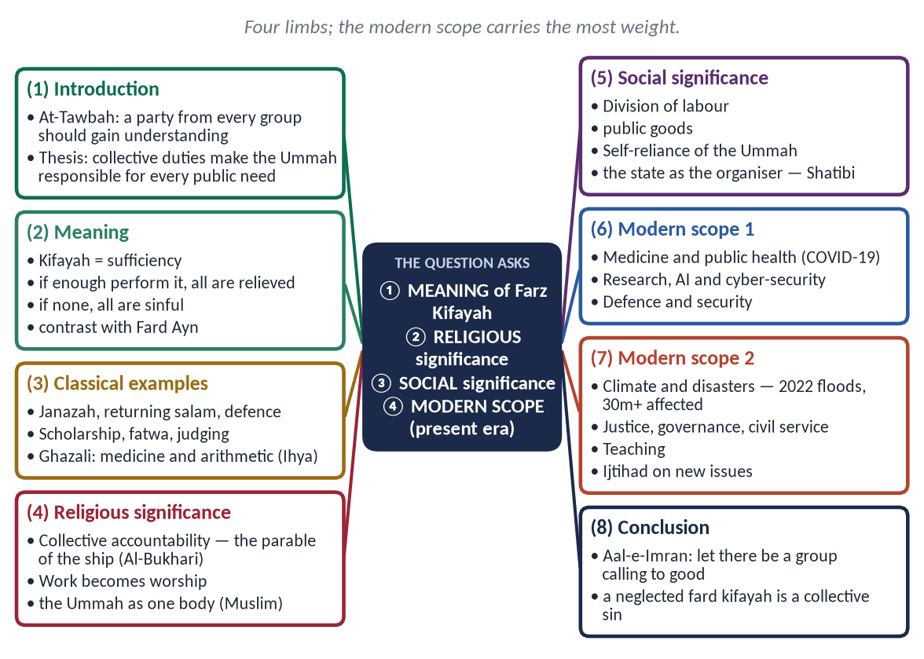
Figure 13 · The answer map: every branch is one numbered heading of the model answer below.

Decoding the question
- 'What is meant' — definition, with the contrast to Fard Ayn, and classical examples.
- 'Religious and social significance' — two separate sections.
- 'In the present era, which affairs …' — a list of modern fields, each justified from the principle, with Pakistani examples. This is the part that distinguishes a good answer.

The model answer

(1) Introduction
✦ QURAN
﴿وَمَا كَانَ ٱلۡمُؤۡمِنُونَ لِيَنفِرُواْ كَآفَّةٗۚ فَلَوۡلَا نَفَرَ مِن كُلِّ فِرۡقَةٖ مِّنۡهُمۡ طَآئِفَةٞ لِّيَتَفَقَّهُواْ فِي ٱلدِّينِ وَلِيُنذِرُواْ قَوۡمَهُمۡ إِذَا رَجَعُوٓاْ إِلَيۡهِمۡ لَعَلَّهُمۡ يَحۡذَرُونَ﴾
“And it is not for the believers to go forth [to battle] all at once. For there should separate from every division of them a group [remaining] to obtain understanding in the religion and warn their people when they return to them that they might be cautious.” (At-Tawbah, Quran)
➜ It is not for the believers to go forth all together; why should not a party from every group go forth to gain understanding of the religion, and warn their people when they return?

Islamic law does not address only the individual. Some duties are placed on the community as a whole: they must be done, but not by everyone. These are the fard kifayah — the collective obligations. The concept makes the Ummah responsible for every public need — from burying the dead to curing the sick and defending the land — and it gives a religious meaning to every profession that serves society. This answer explains its meaning, its religious and social significance, and its scope in the present era.

(2) The meaning of Farz Kifayah

(i) Literal meaning
Kifayah means sufficiency — what is enough.

(ii) Technical meaning
A duty whose performance is required by the Shariah without regard to who performs it. If a sufficient number perform it, the obligation is lifted from everyone; if no one performs it, the whole community is sinful.

(iii) The contrast with Fard Ayn
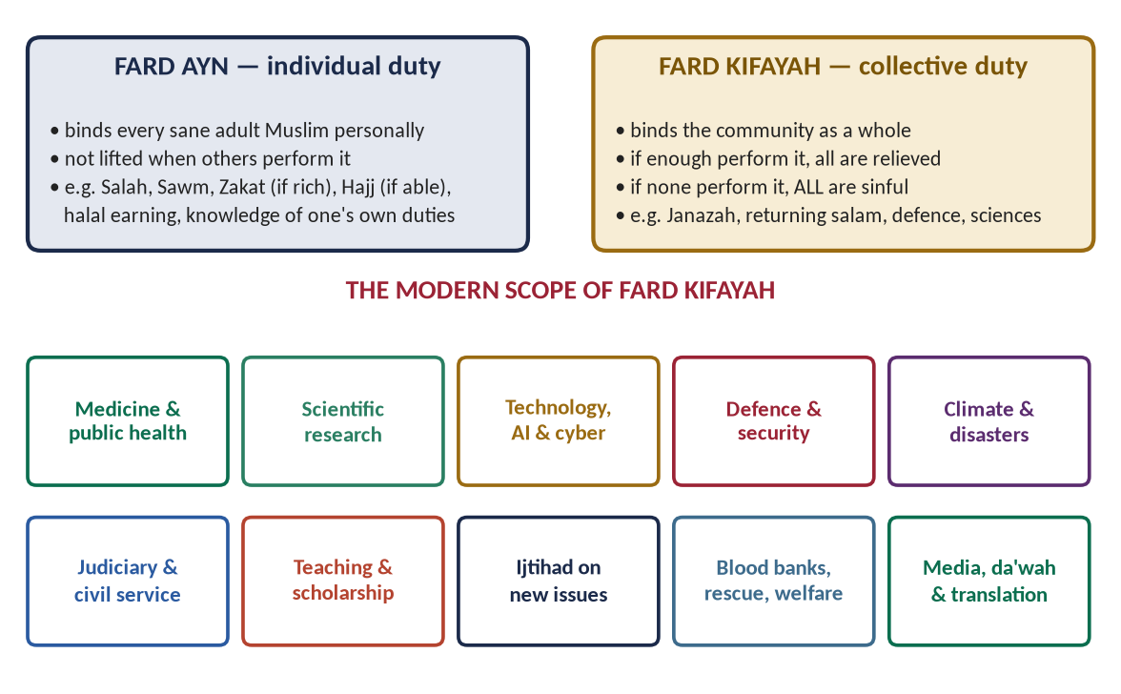
Figure 14 · Fard Ayn and Fard Kifayah, and the modern scope of the collective duty.
Fard Ayn binds every Muslim personally — prayer, fasting, Zakat for the owner of nisab, Hajj for the able. Fard Kifayah binds the community and is performed by those able and qualified.

(iv) Classical examples
- (a) The funeral prayer and burial.
- (b) Returning the salam in a group.
- (c) Defence of the Muslim lands in normal times.
- (d) Enjoining good and forbidding evil at the level of society (Aal-e-Imran: 'let there be among you a group …').
- (e) Advanced religious learning, issuing fatwas and judging.
- (f) The worldly sciences and crafts on which the community depends.
✦ SCHOLARLY VIEW
Imam Al-Ghazali · Ihya Ulum al-Din, Book of Knowledge
Ghazali counts medicine, needed for the health of bodies, and arithmetic, needed for transactions and inheritance, as fard kifayah: if a town has no one skilled in them, all its people are sinful.
➜ A classical master makes science and professions a religious duty.

(3) The religious significance of Farz Kifayah

(i) Collective accountability before Allah
✦ HADITH
مَثَلُ الْقَائِمِ عَلَى حُدُودِ اللَّهِ وَالْوَاقِعِ فِيهَا كَمَثَلِ قَوْمٍ اسْتَهَمُوا عَلَى سَفِينَةٍ … فَإِنْ يَتْرُكُوهُمْ وَمَا أَرَادُوا هَلَكُوا جَمِيعًا، وَإِنْ أَخَذُوا عَلَى أَيْدِيهِمْ نَجَوْا وَنَجَوْا جَمِيعًا
“The example of those who keep Allah's limits and those who transgress them is that of people on a ship … if they leave them, all will perish; if they restrain them, all will be saved.” (Al-Bukhari)
➜ The ship of society sinks or sails together.

(ii) Worldly work becomes worship
The doctor, the engineer, the researcher and the soldier who serve the community's need with right intention are performing a religious obligation.

(iii) The Ummah as one body
✦ HADITH
مَثَلُ الْمُؤْمِنِينَ فِي تَوَادِّهِمْ وَتَرَاحُمِهِمْ وَتَعَاطُفِهِمْ مَثَلُ الْجَسَدِ
“The believers, in their love, mercy and kindness to one another, are like one body.” (Muslim)
➜ Each organ serves the whole — the living meaning of fard kifayah.

(iv) Excellence in every profession
Because the duty is to Allah, it must be done well — 'Allah loves, when one of you does a work, that he perfects it' (Al-Bayhaqi).

(4) The social significance of Farz Kifayah

(i) Division of labour
No one can be doctor, judge, soldier and scientist at once; the concept distributes the community's tasks.

(ii) Public goods
Health, education, justice, defence and infrastructure — needs that no individual can meet alone.

(iii) Self-reliance of the Ummah
A Muslim society that fails to produce its own scientists and physicians becomes dependent — and, in the jurists' language, collectively sinful.

(iv) The state as organiser
✦ SCHOLARLY VIEW
Imam Al-Shatibi · Al-Muwafaqat
Shatibi explains that a fard kifayah, though addressed to all, is carried out by those qualified for it, and that people should be guided into the tasks the community needs according to their abilities.
➜ Fard kifayah implies planning — the natural role of the modern state.

(5) The scope of Farz Kifayah in the present era

(i) Medicine and public health
Doctors, nurses, epidemiologists and vaccine researchers. The COVID-19 pandemic showed health workers performing a collective duty for the whole nation.

(ii) Scientific research and technology
Pakistan spends well under one per cent of its GDP on research and development. Research in artificial intelligence, cyber-security, agriculture, water and energy is a collective duty.

(iii) Defence and security
A capable defence and law-enforcement system protects life and faith — a classical fard kifayah in modern form.

(iv) Climate change and disaster management
The 2022 floods affected more than 30 million Pakistanis. Early warning, disaster response and environmental protection fall within the collective duty to protect life (a Maqsad of the Shariah).

(v) Justice, governance and the civil service
Honest judges and competent civil servants are needed by every community; their absence is a collective failure.

(vi) Education
Pakistan has millions of out-of-school children; teaching, especially in neglected areas, is a collective obligation.

(vii) Religious scholarship and Ijtihad
Qualified muftis and scholars to answer new questions in finance, medicine and technology (T9).

(viii) Welfare and rescue
Blood donation, rescue services, orphan care and disability support.

(ix) Media, translation and da'wah
Presenting Islam accurately, countering Islamophobia, and translating knowledge into national languages.

(x) Economic self-reliance
Food security, industry and interest-free finance, so that the Ummah does not depend on others for its basic needs.
PAKISTAN ANGLE
Many of these duties are carried by the state through its hospitals, universities, courts, armed forces and disaster authorities. Citizens fulfil their share through their professions and their taxes — which gives honest work and honest tax-paying a religious meaning.

(6) When the collective duty becomes personal — and who organises it

(i) From Fard Kifayah to Fard Ayn
A collective duty becomes an individual duty when only one person can perform it or the responsible fail: the only doctor at an accident must treat the injured; when a town is attacked, its defence falls on every able person in it.

(ii) The actors
Actor | Role in fulfilling Fard Kifayah
The state | Plans and funds health, education, research, defence, justice, disaster management
Scholars | Identify new collective needs; guide Ijtihad
Universities | Produce the specialists the Ummah needs
Civil society | Trusts, hospitals, rescue services, blood banks
Individuals | Choose professions to serve the community; pay taxes honestly

(iii) The warning of neglect
Muslim-majority countries together produce only a small share of the world's scientific research. By the jurists' own rule, a neglected fard kifayah is a collective sin — which turns the Ummah's knowledge gap into a religious question.

(7) Conclusion
Farz Kifayah is the Islamic answer to the question 'who is responsible for society's needs?' — everyone, until enough have acted. Its religious significance lies in collective accountability and in making work worship; its social significance lies in the division of labour, public goods and self-reliance. In the present era its scope extends to medicine, science, technology, defence, climate, justice, education, scholarship, welfare and media. A community that neglects them is, in the words of the jurists, sinful as a whole.
✦ QURAN
﴿وَلۡتَكُن مِّنكُمۡ أُمَّةٞ يَدۡعُونَ إِلَى ٱلۡخَيۡرِ وَيَأۡمُرُونَ بِٱلۡمَعۡرُوفِ وَيَنۡهَوۡنَ عَنِ ٱلۡمُنكَرِۚ وَأُوْلَـٰٓئِكَ هُمُ ٱلۡمُفۡلِحُونَ﴾
“And let there be [arising] from you a nation inviting to [all that is] good, enjoining what is right and forbidding what is wrong, and those will be the successful.” (Aal-e-Imran, Quran)
➜ 'Let there be among you a group calling to good, enjoining what is right and forbidding what is wrong — those are the successful.'

Why this answer scores
- Meaning is sharpened by the contrast with Fard Ayn and by classical examples.
- Religious and social significance are two separate sections, each evidenced.
- The modern scope is concrete: ten fields, each with a Pakistani example — exactly the 'present era' the examiner asked for.

